PHYTOPHTHORA BLIGHT OF CUCURBITS

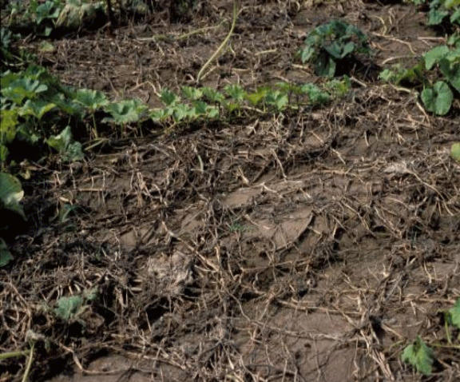
Phytophthora blight, caused by Phytophthora capsici, is one of the most serious threats to production of cucurbit crops (cucumbers, melons, pumpkins, and squash) in Illinois and many other cucurbit growing areas in the United States, as well as in the world. Phytophthora blight also affects eggplants, peppers, tomatoes, and other crops. In recent years, Phytophthora blight occurred widely in Illinois, causing yield losses up to 100% in cucumber, cantaloupe, jack-o-lantern pumpkin, processing pumpkin, squash, and watermelon fields (Figure 1).
Figure 1. Phytophthora foliar blight and fruit rot, caused by Phytophthora capsici. Entire field was affected.

SYMPTOMS

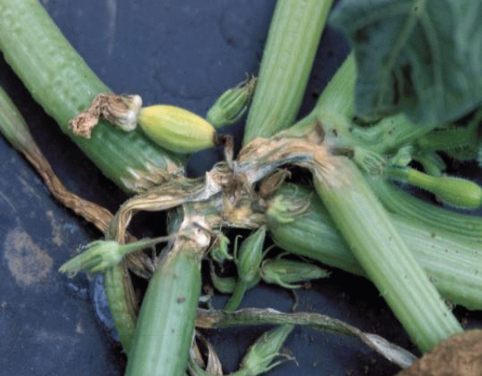
Phytophthora capsici can infect the host plant at any stage of growth. It causes seedling damping-off, root and crown rot, leaf spots, stem lesions, foliar blight, and fruit rot. Pre-emergence and post-emergence damping-off have been widely observed in commercial fields, particularly in pumpkin fields. Phytophthora crown rot commonly occurs in Illinois, but Phytophthora root rot has not been widely observed. Crown rot causes the entire plant to collapse and die in a short period of time (Figure 2). Leaf spots are dark brown, one to several centimeters inches in diameter (Figure 3). Vines can be affected at any part. The lesions are dark brown, water-soaked, and girdle the stem (Figure 4), causing the stem to collapse and die. Phytophthora foliar blight and fruit rot (Figures 5-7) are very common in cucurbit crops. Fruit rot generally starts on the side of the fruit that is in contact with the ground. However, pumpkin fruit are especially prone to infection at the top of the pumpkin, where the fruit is attached to the stem. The depression in the fruit surrounding the stem attachment serves as a reservoir of moisture providing favorable conditions for infection. Infection of a fruit may also start at the site where an infected leaf or infected vine comes in contact with the fruit. Fruit rot typically appears as a water-soaked lesion, expands, and becomes covered with fluffy white mold. Fruit can become completely affected and collapse. Fruit rot can also develop after harvest.
Figure 2. Crown rot of summer squash caused by Phytophthora capsici.

DISEASE CYCLE

Phytophthora capsici is a soilborne pathogen that can survive in the field for several years. The pathogen survives between crops as oospores or mycelium in infected tissue. An oospore is thick-walled sexual spore and is formed when mycelia of two opposite mating types (similar to male and female) grow together.
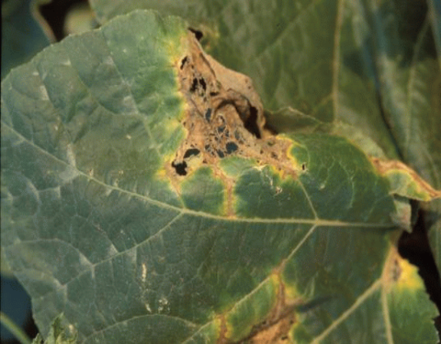
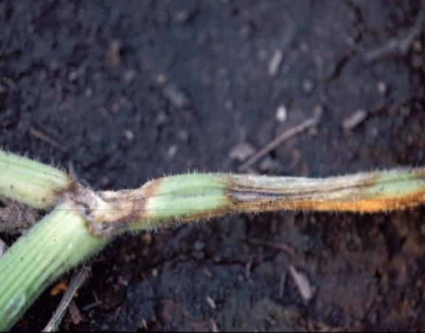
Oospores are resistant to desiccation, cold temperatures, and other extreme environmental conditions, and can survive in the soil, in the absence of a host plant, for many years. Oospores germinate and produce sporangia and zoospores (asexual spores). Zoospores are released in water and dispersed by irrigation or surface water. Zoospores are able to swim for several hours and infect plant tissues. Abundant sporangia are produced on infected tissues, particularly on affected fruit, and dispersed by water or through the air. Sporangia either germinate and infect host tissues, or several zoospores form inside each sporangium and are released in water. If the environmental conditions are conducive, the disease develops rapidly.
Figure 3. Leaf spots of pumpkin, caused by Phytophthora capsici.

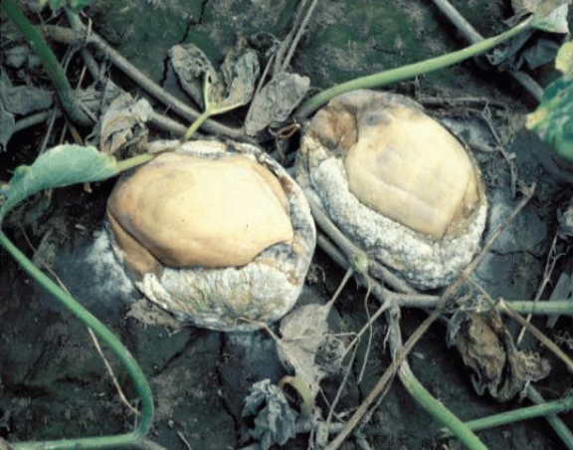
Soil moisture conditions are important for disease development. Sporangia form when soil is at field capacity and they release zoospores when soil is saturated. The disease is usually associated with heavy rainfall, excessive-irrigation, or poorly drained soil. Frequent irrigation increases the incidence of the disease.
Figure 4. Stem lesions of pumpkin, caused by Phytophthora capsici.

DISEASE MANAGEMENT

No single method is available to provide adequate control of Phytophthora blight. A combination of measures should be practiced to reduce the damage caused by P. capsici on cucurbits. The most effective practice in controlling P. capsici is preventing the pathogen from being moved into a new field. The following practices can help to manage Phytophthora blight in cucurbit fields.
Figure 5. Fruit rot of processing pumpkin, caused by Phytophthora capsici.

1. Select fields with no history of Phytophthora blight.

2. Select fields that did not have cucurbit, eggplant, pepper, or tomato for at least 3 years. No rotation period has been established for effective management of Phytophthora blight of cucurbits in Illinois.

3. Select fields that are well isolated from infested fields with P. capsici.

4. Select well-drained fields. Do not plant the crop in the areas of the field which do not drain well.

- Clean farm equipment of soil between fields.

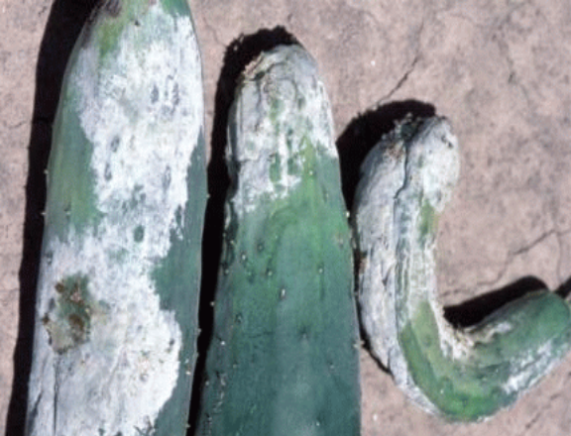
6. Plant non-vining crops (i.e., summer squash) on dome-shaped raised beds (approximately 22 cm high).

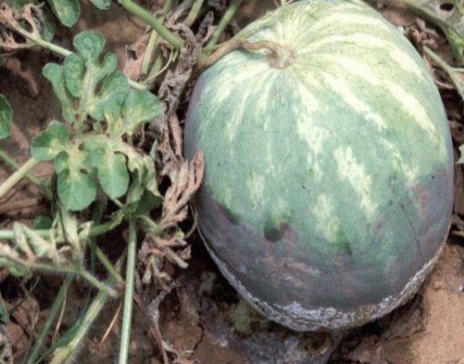
7. Plant resistant varieties, if available.
Figure 6. Fruit rot of watermelon, caused by Phytophthora capsici.

8. Avoid excessive irrigation.

9. Do not irrigate from a pond that contains water drained from an infested field.

10. Do not work in wet fields.
Figure 7. Fruit rot of cucumber, caused by Phytophthora capsici.
11. Scout the field for the Phytophthora symptoms, especially after major rainfall, and particularly in low areas.

12. When symptoms are localized in a small area of the field, disk the area.

13. Discard infected fruit, but not in the field.

14. Do not save seed from a field where Phytophthora blight occurred.

15. Remove healthy fruit from the infested area as soon as possible and check them routinely.

16. Do not display fruit for sale in an area that is infested with P. capsici.

17. Apply effective fungicides, when recommended. Aliette is registered for control of P. capsici. However, Aliette did not provide effective control of Phytophthora blight in processing pumpkin and bell pepper fields in Illinois. Seed treatment with either mefenoxam [Apron XL LS at the rate of 0.64 fl oz/100 lb (0.42 ml/kg) seed] or metalaxyl [Allegiance FL at the rate of 1.5 fl oz/100 lb (0.98 ml/kg) seed] effectively protects seedlings of cucurbits until 5 weeks after sowing seed. Applications of dimethomorph [Acrobat 50 WP at the rate of 6.4 fl oz/A (434 g/hectare)] plus copper sulfate [i.e., Cuprofix Disperss at the rate of 2 lb/A (2.25 kg/hectare)], or Tanos 50WG at the rate of 8 oz/A (560 g/hectare) plus copper sulfate [Cuprofix or Kocide-200 at the rate of 2 lb/A (2.25 kg/hectare)], at weekly intervals, provide effective protection against foliar blight and fruit rot, caused by P. capsici in cucurbit fields. Crop losses to Phytophthora blight can be minimized by combining Apron seed-treatment with weekly applications of Acrobat plus copper alternated with Tanos plus copper. For up-to-date information on using chemicals to control Phytophthora blight of cucurbits, you may refer to the current edition of publication number C1373, “Midwest Vegetable Production Guide for Commercial Growers” (http://www.entm.purdue.edu/entomology/ext/targets/ID/index.htm). This publication is available from ITCS, University of Illinois P345, 1917 S. Wright St., Champaign, IL 61820 or call 1-800-345-6087. You may also visit the Website http://veg-fruit.cropsci.uiuc.edu for updates on vegetable pathology.

